Name: Korada Vijaya Anjali

Roll No: 21A91A6148

Email: [anjalikorada1008@gmail.com](mailto:anjalikorada1008@gmail.com)

College: Aditya Engineering College, Surampalem

* Launch the VPC with public and private subnets, Routing tables, Internet gateway, NAT gateway.
* It was done in week 3 task.
* Go to AWS RDS to create the database. Create and launch the RDS. For this 1st we need to create a SUBNET GROUP. In RDS we find this subnet group.

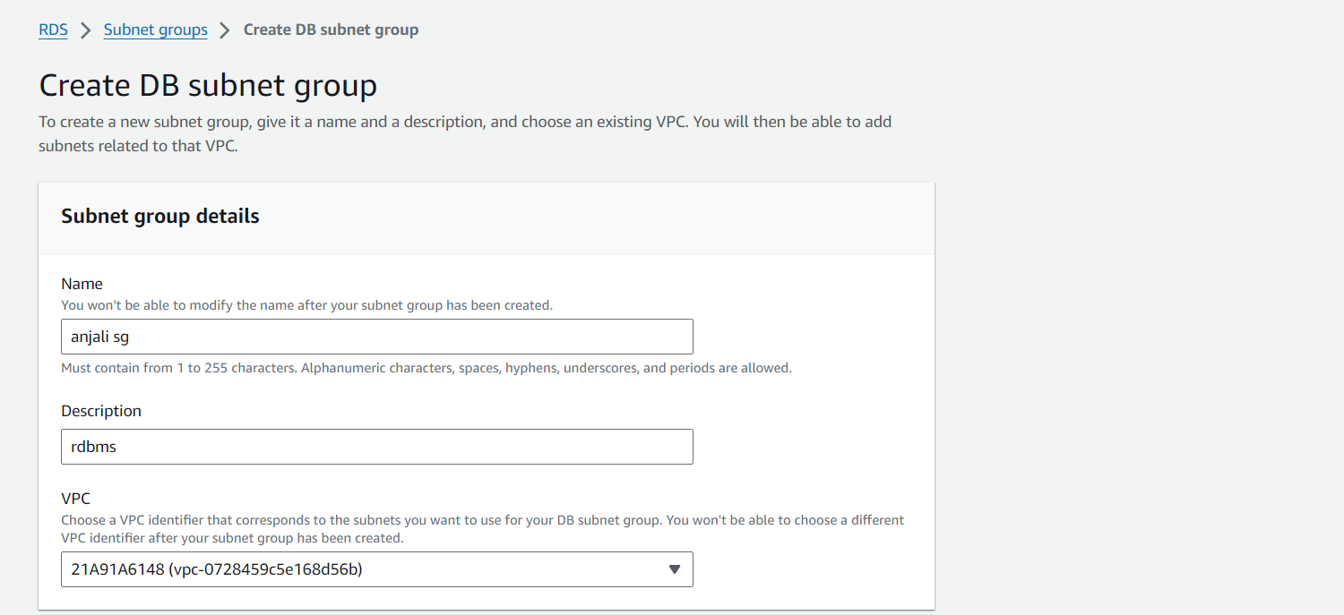

* Create a db subnet group.

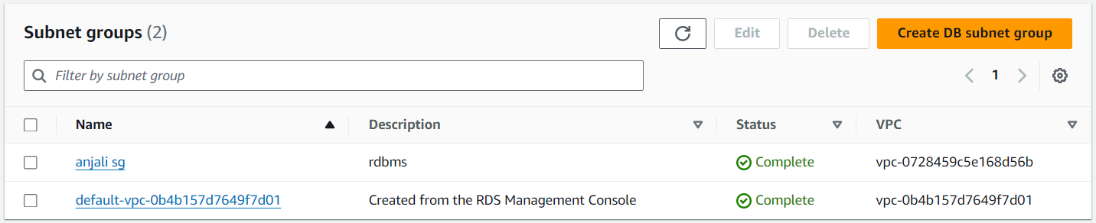

* Create a database sql while creating read the options twice and choose the appropriate ones for our database

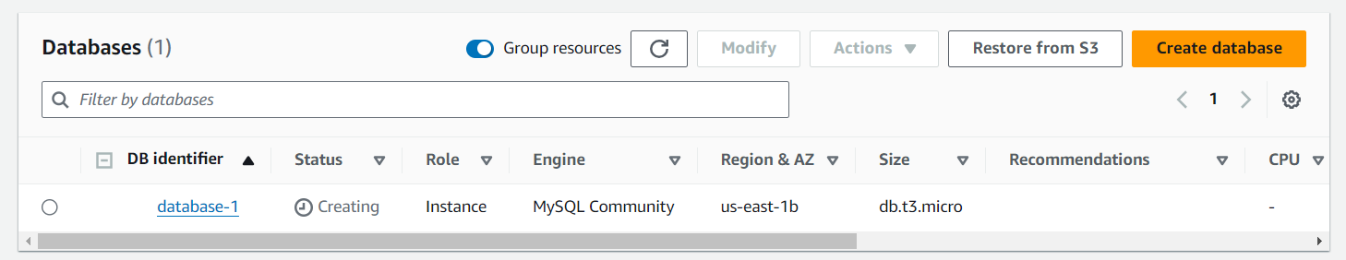

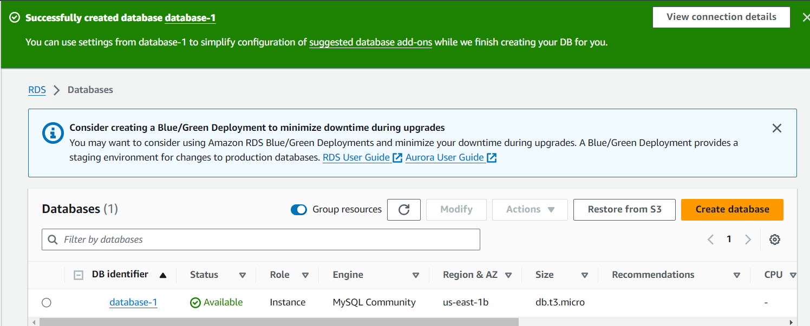

* Now launch a EC2 instance.

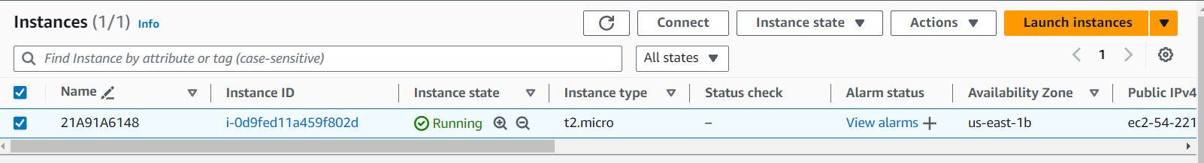

* Create sg for ec2 and database connection

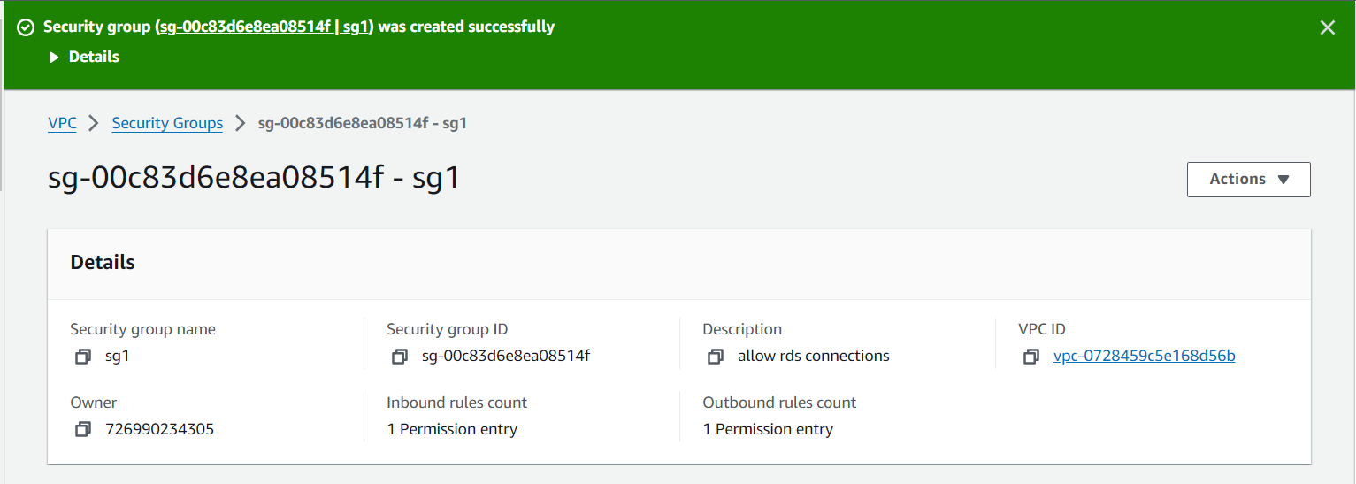

* Set up the rds connection to ec2 we created by using actions-> connection to ec2 -> choose the ec2 you want to connect.

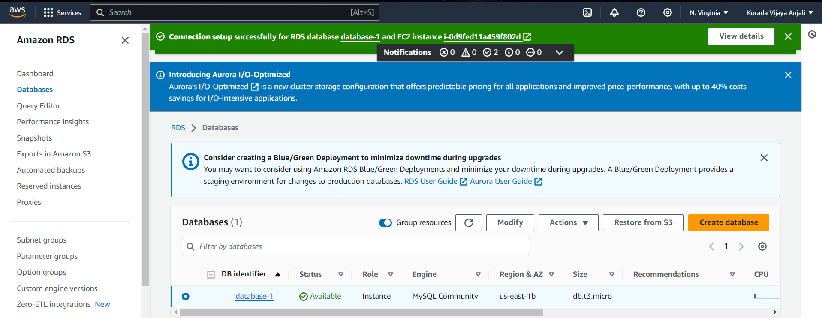

* Connect the ec2 instance using mobaxterm.

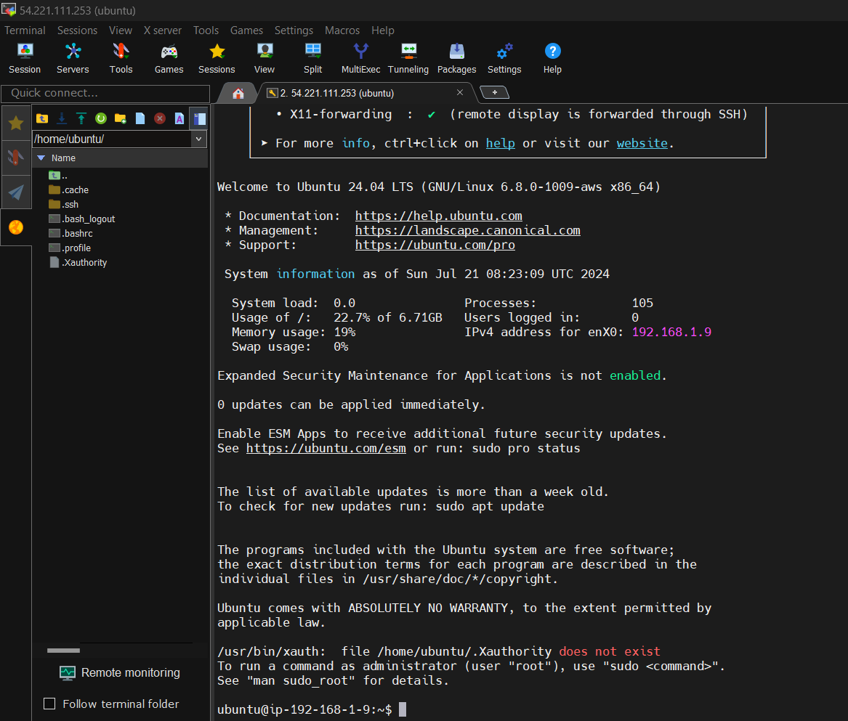

* Use the commands in ec2 instance

1. sudo su
2. apt-get update –y
3. apt-get install mysql-client –y
4. sudo mysql –u admin –p –h (end point of dbms)
5. Then you enter into the database you created

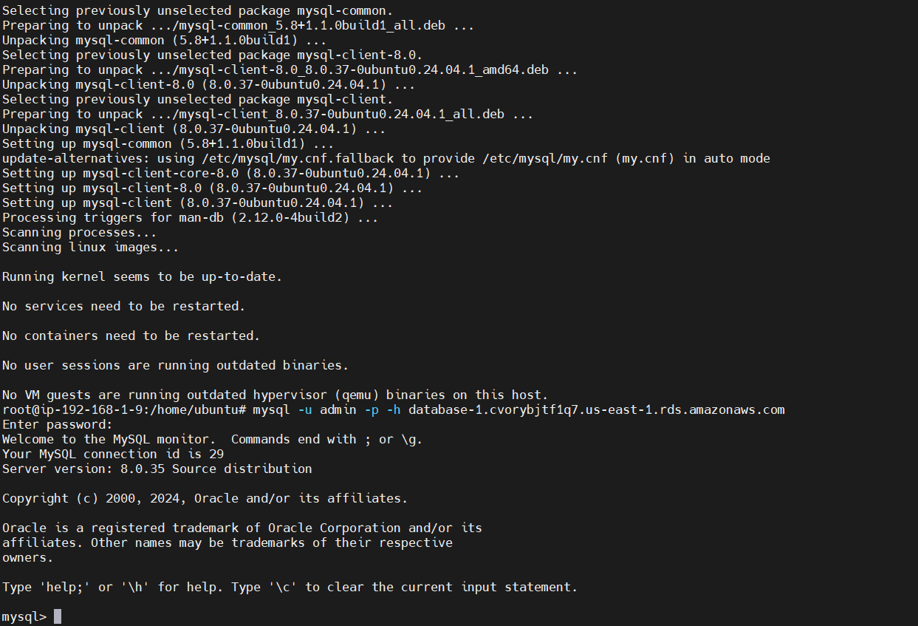

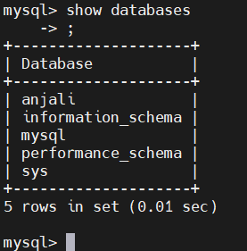

* This is how we connect database in ec2 instace

rt

rds

Private subnet

Public subnet

igw

internet

Ec2 (bation host)

**SUMMARY:**

* Create a VPC.
* Create a 2 subnets (public and private).
* Make one subnet as public by enable the ipv4.
* Create a routing table and associate the 2 subnets.
* Create a internet gateway and attach it with VPC the add its routes to rt.
* Create a NAT gateway and add its routes to RT but is shows errors so create another RT and then associate it with private subnet add the routes then.
* Here we created a VPC correctly.
* Now create a RDS before create a DB subnet group for creating RDS now create it. (here we face some issues with VPC like DHCP solve them by enabling it, create a security group also).
* Create a ec2 instance.
* Now attach the database we created with ec2 in RDS.
* Create a security group by allowing the routes of database here select the sg you created.
* Now your database and ec2 are connected.
* Now connect the ec2 with mobaxterm.
* Using the above commands connect with database we enter into the database now we can work with it.